

**Veeam Service Provider Console VSPC**

**Plugin Configuration Guide**

Contents

Veeam Service Provider Console Configuration Checklist 2

Supported Collection Types 2

Data Sources 2

Requirements 3

Bocada Setup 3

Server Properties 3

Field Definitions 3

Customer Tenant Management 4

Initial Tenant Discovery 4

Updating Tenants (Onboard/Offboard) 6

Troubleshooting and Notes 7

Technical Support 8

# Veeam Service Provider Console Configuration Checklist

While detailed steps are included below, this is an overview of the steps to configure Veeam Service Provider Console (VSPC) collections on your Bocada Data Collection Server:

Verify location, instance, & name of the Veeam Service Provider Console database

If necessary, create a SQL login with Read access on that database

Verify required TCP port(s) has been opened

# Supported Collection Types

The plugin currently supports the following collection types from Veeam Service Provider Console servers:

|  |  |  |
| --- | --- | --- |
| **Collection Type** | **Supported** | **Description** |
| Backup | ✓ | Collects transactional details about backup jobs. Example metrics include, start times, durations, bytes, files, errors etc. |
| Storage |  | Collects point-in-time inventory information. Example metrics include, total recoverable gigabytes (storage), media volume count, media volume status, etc. |
| Policy | ✓ | Collects and stores information on tenants. |

# Data Sources

The plugin relies on the following Veeam Service Provider Console data sources:

* Veeam Service Provider Console Database

# Requirements

**Firewall Ports**

|  |  |  |
| --- | --- | --- |
| **Service** | **Default Port** | **Note** |
| *SQL Server* | 1433/TCP | - |
| *SQL Server browser* | 1434/UDP | Not required when default SQL port specified |

**Veeam Service Provider Console Database**

The Bocada plugin requires access to the Veeam Service Provider Console database with SQL or Windows authenticated user that has *db_datareader* access to run SELECT queries.

# Bocada Setup

### Server Properties

Backup Server Properties determine how the plugin will interface with the Veeam Service Provider Console server and are managed through the Backup Servers view.

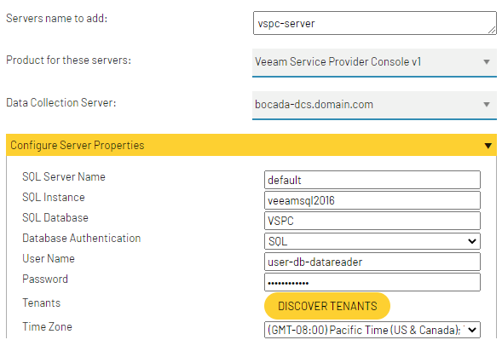

### Field Definitions

#### Server name to add

This must be the name of the Veeam Service Provider Console Server.

#### SQL Server Name

Enter the name of the server where the Veeam Service Provider Console database resides, leave as default if the database resides on the same server in which the Veeam Service Provider Console is installed.

#### SQL Instance

Enter SQL instance where the Veeam Service Provider Console database resides.

#### SQL Database

Enter the Veeam SQL Database name.

#### Database Authentication

Choose Windows or SQL Authentication depending on the type of User that will be used to access the Veeam Service Provider Console database.

#### User Name / Password

Enter the credentials for the SQL or Windows Authenticated user that has permission to run SELECT queries against the Veeam database.

#### Tenants

Clicking “DISCOVER TENANTS” will provide an interface to choose which customer/client tenants to include in reporting (and licensing). For detailed information on how to choose tenants, see Customer Tenant Management

#### Time Zone

Select the time zone where Veeam Service Provider Console server resides. This setting ensures times are displayed consistently in environments that span multiple time zones.

# Customer Tenant Management

Because Veeam Service Provider Console supports management of multiple customers for a Managed Service Provider, the Bocada plugin offers a way to manage which customer tenants are included in the reporting and licensing.

### Initial Tenant Discovery

When first adding a server it is necessary to perform a tenant discovery. Clicking the “DISCOVER TENANTS” button will add the VSPC server to Bocada, save the properties, perform a test connection, and run a policy update to discover available customer/client tenants.

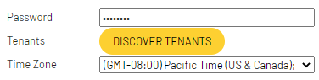

When adding a new VSPC instance expand the Test Connection prior to performing the tenant discovery. Depending on how long discovery takes to complete, clicking again will launch a butterfly control to select which tenants to include in reporting (and licensing).

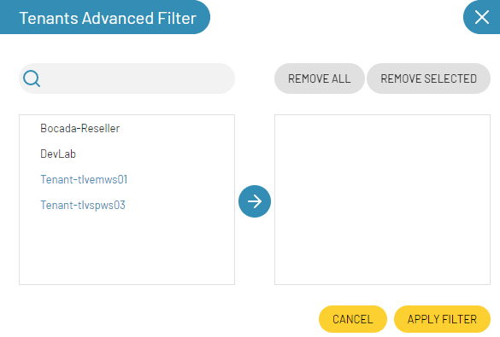

Highlight the available tenants from the left side and click the blue center arrow to include those tenants in reporting and licensing.

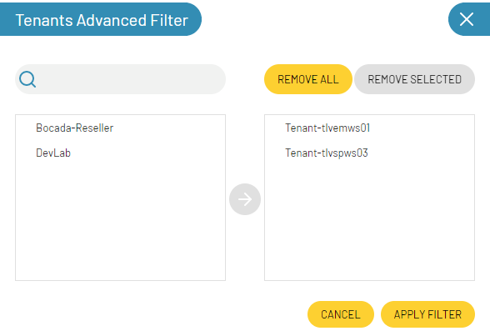

When finished selecting tenants, APPLY FILTER to report on those present on the right side. Upon completing the server configuration, a corresponding set of zones and rules will be created for to reproduce the VSPC multi-tenancy and when rules are run the data for each tenant will be assigned to the corresponding zones.

### Updating Tenants (Onboard/Offboard)

At any point customers can be added to or removed from Bocada reporting by following the above process when editing the VSPC server. When offboarding a customer (removing from the reporting) additional steps should also be taken to remove them from report distribution. Any unit count related to that customer will automatically fall off the license count after 35 days.

# Reporting Notes

The following is how data points within Veeam Service Provider Console are normalized and reported in Bocada.

|  |  |
| --- | --- |
| **Bocada Data** | **Veeam O365 Data** |
| Job Group | Job Name |
| Policy | Job Name |
| Backup Client | VM or other protected resource |
| Target | Additional backup detail  (typically, same as Backup Client) |
| Group Session | Group ID from the VSPC database |
| Description | Job ID from VSPC database |

Veeam Service Provider console only presents the byte counts of backups at a group/policy level rather than at the backup client or resource (e.g. VM) level. This results in Bocada reporting a single parent job with client name = *<JobGroup>-parent* reporting the byte count of the group while the remaining jobs report other backup details.

The example below shows all elements of a job and how they are reported under the same Bocada “Job Group”, with the parent client () containing the byte count of the group.

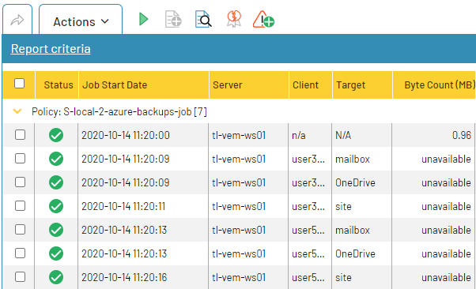

# Troubleshooting and Notes

**Allowing SQL authentication access to the Veeam Service Provider Console instance:**

#### Change Server Authentication Mode

<https://docs.microsoft.com/en-us/sql/database-engine/configure-windows/change-server-authentication-mode?view=sql-server-ver15>

#### Create a Database User

<https://docs.microsoft.com/en-us/sql/relational-databases/security/authentication-access/create-a-database-user?view=sql-server-ver15>

*Notes when adding a user*

* Enforce password expiration: If is selected (default) then the Bocada collections will fail when the password expires. It is recommended to disable password expiration enforcement.
* [Server Role](https://docs.microsoft.com/en-us/sql/relational-databases/security/authentication-access/server-level-roles?view=sql-server-ver15): The Read-only user created need only have the public role, which is the most limited. However, this use must have the db_datareader user mapping mapped to the Veeam database in order to read table data.
* [User Mapping](https://docs.microsoft.com/en-us/sql/relational-databases/security/authentication-access/database-level-roles?view=sql-server-ver15): To assign read privileges, ensure you assign the *db_datareader* role to the Veeam database mapping

# Technical Support

For technical support or a copy of our standard support agreement, please contact us.

**E-mail:** [support@bocada.com](mailto:support@bocada.com)

**Support Portal:** http: <https://bocada-support.force.com/s/>

**Phone:** +1-425-898-2400

**Copyright © 2021 Bocada LLC.** All Rights Reserved. Bocada and BackupReport are registered trademarks of Bocada LLC. Vision, Prism, vpConnect, and the Bocada logo are trademarks of Bocada LLC. Other product names mentioned herein may be trademarks or registered trademarks of their respective companies.

Protected by U.S patents 6,640,217; 6,708,188; 6,745,210; 7,457,833; 7,469,269; 7,496,614; 8,407,227

The material in this manual is for information only and is subject to change without notice. While efforts have been made to ensure accuracy, Bocada LLC assumes no liability resulting from errors or omissions in this document, or from the use of information contained herein.

Bocada LLC reserves the right to make changes in the product design and documentation without reservation and without notification to its users. 2021-05-12